UAMS News Bureau
Office of Communications & Marketing
4301 West Markham # 890
Little Rock, AR 72205-7199
uamshealth.com/news
News Release
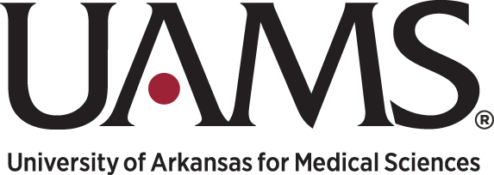
Nov. XX, 2023
Media Contacts:
Leslie W. Taylor, 501-686-8998
Wireless phone: 501-951-7260
leslie@uams.edu

Yavonda Chase, 501-686-8995
Wireless phone: 501-416-0354
Yavonda@uams.edu

Cardiac Surgeon John Streitman, M.D., Joins
UAMS, to Lead Cardiovascular Surgery Program

LITTLE ROCK — John Emory Streitman, M.D., a board-certified cardiac surgeon with a special interest in complex cardiovascular cases, joined the University of Arkansas for Medical Sciences (UAMS) as an associate professor in the UAMS College of Medicine Department of Surgery.

He will lead the cardiovascular surgery program.

“Dr. Streitman is a highly experienced cardiac surgeon who brings a wealth of expertise to all forms of cardiac and vascular surgery,” said J. Paul Mounsey, M.D., Ph.D., professor and director of the College of Medicine Division of Cardiovascular Medicine and director of UAMS’ cardiovascular services. “With him at the helm, I see a bright future for our cardiovascular surgery program.”

“I am thrilled to have Dr. Streitman join our department and our institution,” said Ronald D. Robertson, M.D., chair of the College of Medicine Department of Surgery. “He brings a wealth of experience and knowledge to our cardiovascular surgery program. We look forward to the change in culture and growth the program will experience over the coming years.”

Streitman came to UAMS from Methodist Le Bonheur Germantown Hospital in Memphis. He was recruited to Le Bonheur in 2022 to stabilize and grow a cardiac surgery program as its medical director. Previously, he was chief medical director of cardiac surgery at Northside Hospital in St. Petersburg, Florida, part of HCA Healthcare, for which he also directed its West Florida Division of Cardiovascular Surgery and its structural heart program.
Previously, Streitman co-directed cardiovascular and thoracic surgery at Lakeland Regional Medical Center in Lakeland, Florida, served as chief medical director of cardiac surgery for Baptist Health System in San Antonio, Texas, and worked as a cardiovascular surgeon in Dothan, Alabama, and Pinehurst, North Carolina.

Streitman obtained his medical degree in 1999 from the University of Texas Health Science Center in San Antonio. He completed a thoracic and cardiovascular surgery residency at University of Florida Health in Gainesville, Florida, and a general surgery residency at Scott and White Memorial Hospital at the Texas A&M Health Science Center in Temple, Texas.

UAMS is the state's only health sciences university, with colleges of Medicine, Nursing, Pharmacy, Health Professions and Public Health; a graduate school; a hospital; a main campus in Little Rock; a Northwest Arkansas regional campus in Fayetteville; a statewide network of regional campuses; and seven institutes: the Winthrop P. Rockefeller Cancer Institute, Jackson T. Stephens Spine & Neurosciences Institute, Harvey & Bernice Jones Eye Institute, Psychiatric Research Institute, Donald W. Reynolds Institute on Aging, Translational Research Institute and Institute for Digital Health & Innovation. UAMS includes UAMS Health, a statewide health system that encompasses all of UAMS' clinical enterprise. UAMS is the only adult Level 1 trauma center in the state. UAMS has 3,275 students, 890 medical residents and fellows, and five dental residents. It is the state's largest public employer with more than 12,000 employees, including 1,200 physicians who provide care to patients at UAMS, its regional campuses, Arkansas Children's, the VA Medical Center and Baptist Health. Visit www.uams.edu or www.uamshealth.com. Find us on Facebook, X (formerly Twitter), YouTube or Instagram.

Like us, we’re social:

